Damien Hirst Artistic Works and Contributions to the Society
University Affiliation
Student’s Name
Course
Professor
Introduction
Daminen Hirst was born in British in 1975. Hirst was an assemblagist, painter and conceptual artist who made deliberate provocations through art to address various issues in the society including morality, death, and rebirth, Vanitas and beauty, technology as well as medicine. Damien Hirst is a Conceptual craftsman since his work regularly outweighs other customary issues or thoughts. This is depicted by his work with dead creatures and safeguarding them, which is frequently disapproved by people. Hirst is known to be a contemporary craftsman with his work being current and spread all through the nation in displays, shows, and even private collections. Damien Hirst is a generally known artist that is known to be perhaps the most extravagant artist to be alive today. His work moves numerous individuals for a wide range of reasons and is known for its contention, excellence, and unpredictable style (Blanché). This paper looks into the contributions made by Hirst, some of his significant works of art and his influence on society.
Hirst’s Contributions in Art
Hirst has used a changed routine with regards to establishment, sculpture, drawing, and painting to explore the mind-boggling connection between workmanship, life, and death since the late 1980s. He explained, "Art is about existence and it can't generally be tied in with whatever else … there is nothing else," Hirst's artistic work explores and justifies contemporary conviction systems, and dissects the strains and vulnerabilities at the core of human behavior (Blanché).
Hirst built up his enthusiasm for investigating the "inadmissible thought" of death as a youngster in Leeds. Since the age of sixteen, Hirst regularly walked to the life systems branch of Leeds Medical School so as to make life arts ('With Dead Head' (1991)). The encounters made him set up the troubles that he saw in accommodating the possibility of death throughout everyday life (Wainwright). When he was talking about the prominence of death in his artistic work ('A Thousand Years' (1990)) he made it clear: "You can startle individuals with death or their very own thought mortality, or it can really give them power.”
At Goldsmiths, Hirst's comprehension of the contrast between drawing and model changed essentially, and he started taking a shot at a portion of his highly significant arrangement. The 'Medicine Cabinets' made in his subsequent year consolidated the feeling of moderation with Hirst's perception that "science is the new religion for some individuals. It's as straightforward and as muddled as that extremely." This art was one of his generally suffering topics that was intensely depicted in the establishment work, 'Pharmacy' (1992).
While in his subsequent year, Hirst imagined and formed ‘Freeze’ – a group show in three stages. The show of Goldsmith's scholars is generally recognized to be the stepping stone for Hirst. For its last stage, he made two paintings with hued spots on to the distribution center dividers. Hirst portrays the spot artistic creations as a method for "binding the delight of shading", and clarifies that they gave an answer for all issues he'd recently had with painting. It has turned out to be among the craftsman's highly productive and unmistakable arrangement, and in January 2012 the paintings were shown in a demonstration of phenomenal scope over eleven Gagosian Gallery areas around the world (Wainwright).
From his contribution in 'Freeze' in 1988, curatorial undertakings have stayed essential to the craftsman. In 1994 he sorted out the global gathering show 'Some Went Mad, Some Ran Away' at the Serpentine Gallery. For more than 10 years after the scenario, he explained that he prefers collection to comprise a "Maps of a man's life", he curated a respectable show from his 'Murder me' group: 'At the breaking point, there might be light' (Cumming).
Significant Works by Damien Hirst
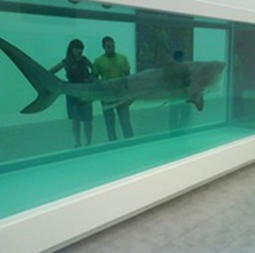
  - Damien Hirst: The Physical Impossibility of Death in the Mind of Someone Living (1991)
In 1991 Hirst initiated his artistic work on 'Natural History', which is seen to be his most prominent work. Through protecting animals in moderate steel and glass tanks filled with formaldehyde gas, Hirst expected to make a "zoo of dead creatures". In 1992, his work on the shark piece, 'The Physical Impossibility of Death in the Mind of Someone Living' (1991) was displayed at the Saatchi Gallery's 'Young British Artists I' presentation. The shark, depicted by the artist as a "thing to portray an inclination", remains as one of the highly significant images of present-day British artistry and mainstream the values of the British society during the 1990s (Wainwright). The course of action epitomizes Hirst's excitement for display frameworks. The glass walls that he uses for both 'Typical History' works and in vitrines, for instance, 'The Acquired Inability to Escape' (1991), act to portray the artistic work's space, while simultaneously commenting on the "delicacy of presence".
Hirst kept on setting the craftsmanship world ablaze with his work at 1993, Venice Bienniale, a prestigious worldwide artistic show. There he indicated "Mother and Child Divided," an establishment piece that included a cut-up bovine and her calf showed in four vitrines, or glass cases, loaded up with formaldehyde. With his questionable and some of the time abhorrent works, Hirst before long ended up a standout amongst other known specialists in Britain. He won the renowned Turner Prize in 1995. "It's astounding what you can do with an E in A-Level craftsmanship, a bent creative mind, and a cutting tool," Hirst said in his acknowledgment discourse (Cumming).
In 2007, Hirst launched the astounding, 'For the Love of God' (2007): a platinum cast of a skull set with 8,601 immaculate pave-set precious stones, at the White Cube show 'To excess'. In the following year, he made the extraordinary stride of abandoning exhibition inclusion in selling 244 new artistic works at Sotheby's auction house in London (Aslet). Portraying the work as a tool for coordinating the craftsmanship advertise, the 'Lovely Inside My Head Forever' sale pursued Hirst's Sotheby's occasion in 2004 where the whole substance of the skilled worker's restaurant experience, Pharmacy, were put up for sale.
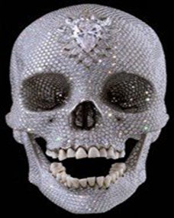
  - Damien Hirst: For the love of God (2007).
Hirst's specialty was displayed in various performance and gathering shows, including real reviews at the Museo Archeologico Nazionale in Naples (2004) and Tate Modern (2012) in London. He likewise composed books, structured cafés, teamed up on popular music extends, and tried different things with film (Cumming). 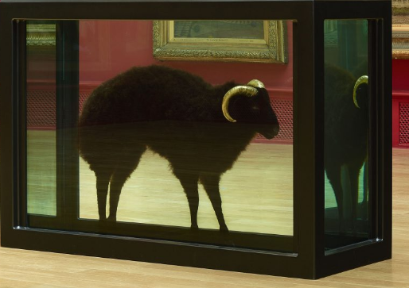
  - Damien Hirst: Black Sheep with Golden Horns (2009).
Influence on Other Artists
While not every person was excited with his paintings and other works, Hirst acquired monetary support from Charles Saatchi, promoting titan and workmanship gatherer. Saatchi loaned budgetary help to Hirst, and then collected Hirst's pieces, that propelled the craftsman's notoriety. Saatchi purchased two of Hirst's medicine bureau models which one pundit later argued that it comprised "a star grouping of still life that express and mirror the human body as a field of vulnerabilities and of cheerful restorative intercessions."
Hirst's full series of 13 screenprints 'The Last Supper' is fused into the showcase. As in 'Pharmacy' (1992), and with the 'Medication Cabinets' arrangement, 'The Last Supper' demonstrates Hirst's enthusiasm for the Minimalist stylish intrigue of restorative bundling, which Hirst has compared to artistic work by Donald Judd and Sol LeWitt. 'The Last Supper' frames some portion of Hirst's continuous assessment of the job of religion and science in contemporary society. On examining the reason for the arrangement he expresses: "Where's God now? God's screwed off. So all these enormous issues – like workmanship and science and malignancy – are on the whole climbing about on this fruitless scene where God used to exist." Damien Hirst surely challenges different artists with his fine arts, he adopts a one of a kind strategy into making work in the manner he utilizes various structures and the sort of media he works with for instance 'jewels'. He takes workmanship to another level (Aslet).
Conclusion
To conclude on the study conducted to investigate the masterful works and commitments of Damien Hirst plainly Hirst has solid energy for 'death' as a topic, he is a certain craftsman who's not hesitant to go for broke. This exposition has made it apparent that aesthetic works by Hirst, his commitments towards craftsmanship and his setting are fundamental to comprehension and acknowledging workmanship in the general public. From the start of his vocation, Hirst conceived a secure system for catching the eye of people in general and pundits. Decaying bodies shocked and pulled in historical center guests, who considered it to be a sort of dare. Pundits were similarly dismayed, less by the craftsmanship but rather more by the high as can be costs (regularly prearranged) paid for it (Wainwright). This kept Hirst at the focal point of the craftsmanship world and increased the estimation of his work, which keeps on directing probably the most noteworthy costs available.

Works Cited
Aslet, William. "The Unlikely Artists Who Inspired Damien Hirst." Sotheby's, 7 Mar. 2018, www.sothebys.com/en/articles/the-unlikely-artists-who-inspired-damien-hirst. Accessed 20 Sept. 2019.
Blanché, Ulrich. "5) Banksy and Damien Hirst." Damien Hirst, 2018, pp. 203-230.
Cumming, Prudence. "Damien Hirst." Yorkshire Sculpture International, 3 Apr. 2019, yorkshire-sculpture.org/artists/damien-hirst/.
Wainwright, Lisa S. "Damien Hirst." Encyclopedia Britannica, 7 July 2019, www.britannica.com/biography/Damien-Hirst.

